Airborne Particle Emission In Subway Stations

PARTICULATE MATTER (PM2.5)

Laurent Elysee

Energy and Environmental Simulation Laboratory ( EESL)

New York City College of Technology

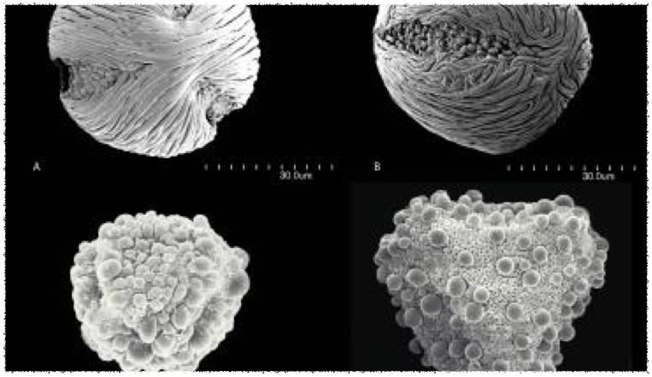Abstract

PM2.5 emissions impinges on human health over a continuous period of exposure. It’s infringement on Subway Air Quality (SAQ) poses a critical threat due to the lack of adequate underground ventilation and fresh air. In NYC subway systems, the hazardous effect on the health of passengers and subway workers show up in many forms of lung diseases and respiratory problems. The risks are particularly high in young children and pregnant women.

This project proposes the execution of viable solutions that can be applied to subway systems in major cities in the world. A combination of cleaner ventilation airways and air purification strategies with PM detection sensors that can help reduce the ambient airborne particles. Filtering systematic process can be applied to reduce and over time eliminate the intake of particulate matter from the human body and in the air. An educational campaign in public library, subway stations and hospitals will be implemented to help raise the awareness of the bad effects of PM2.5

## Introduction

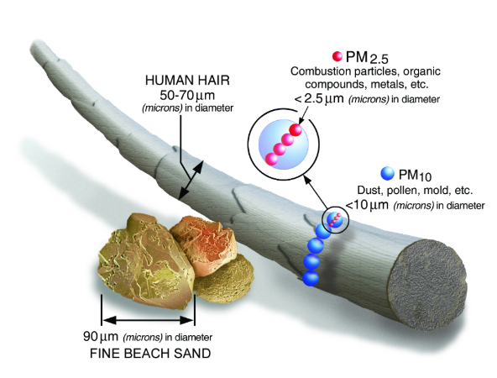Particulate matter (PM) is a complex composition of micrometric particles and liquid droplets derived from organic soot and inorganic particles, which consist of nitrates and sulphates (such as soil, dust, metals and acids).The fundamental of the size of the particle is commonly categoralize by the aerodynamic diameter, which can vary over four orders of magnitude in the atmosphere; the largest ones (coarse fraction), mechanically produced, include pollen grains, mould spores, wind-blown dust from agricultural processes, sea spray, uncovered soil, unpaved roads or mining operations; the smallest ones (fine fraction) are mainly formed from gases by nucleation and coagulation at a low scale. Additionally, the secondary aerosol can be formed by chemical and physical reactions in the atmosphere (as acidic forms from sulphuric/nitric acid and ammonium salts in the presence of ammonia), which creates a carbonaceous fraction composed of organic matter and more importantly elemental carbon, xs

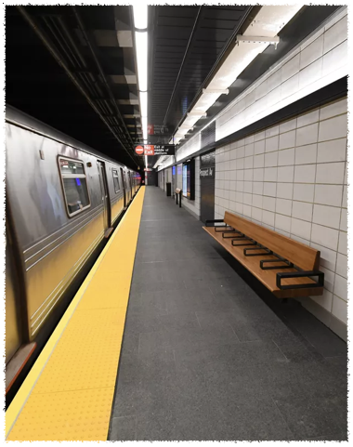 Black Carbon is often defined as the key component of fine particulate matter air pollution, so far the dominant environmental cause of premature death and poor health. PM2.5 , given its size of 2.5 micro meters in diameter, has the capacity to penetrate into the deepest regioins of the lungs and facilitate the transport of toxic compunds into the bloodstream. Globally, 1 in 8 premature deaths are caused by air pollution. Amounting to about 7 million deaths per year.

It is stated that the New York City subway (MTA) is the main transportation medium to over 5 million people on a weekly average. Emphazing the significant impact it could have on commuters and subway workers.

This study will portray an adept state of affairs on BC and PM2.5 concentrated levels in selected subway stations both in Brooklyn and Manhattan. Using Arduino uno sensor sytems, collected data will be analyzed and compared to the levels outside of the subway to accentuate the gravity of the situation.

**Introduction (fixes)**

* Label the pictures – where they came from and short explanation of their importance.
* Add the questions of the comments (MAYBE)
* Change the cover picture